Kerberos

1.in one server need to install the below packages

Yum –y install krb5-server krb5-workstation krb5-libs

2./etc/krb5.conf file

You have to make the KDC server name and kadmin server name and realname should be changed.

Means : Server name where Kerberos is installed that machine ip address

Wherever example is there need to give as Hadoop and also EXAMPLE to HADOOP.

3.we have to create KDC database.

Krb5util create –s

It will ask KDC database key and enter password make it note down.

4.we need to restart the services

Service krb5kdc start

Service kadmin start

5. chkconfig krb5kdc on

Chkconfig kadmin on

6. we have to changes realname in /var/Kerberos/kadm5.acl

[*/admin@example.com](mailto:*/admin@example.com) *

Here above need to replace example with Hadoop

7. we have to create admin principal

How to create admin prinicipal?

kadmin –q “addprinc [admin/admin@hadoop.com](mailto:admin/admin@hadoop.com)”

it will ask password

enter password definitely note down.

8.kadmin –p [admin/admin@hadoop.com](mailto:admin/admin@hadoop.com)

Kadmin:list

Kadmin:listprincs

Kadmin:list_principals

Here we can see admin principal details.

Which means you are able to login admin principal and all admin principal.

Then try to create some test prinical

Addprinc [abc/abc@hadoop.com](mailto:abc/abc@hadoop.com)

Run again listprincs

Like that it..

9. Once this is done,

We need to go to cloudera manager – administration – security – enable Kerberos

Once we go there,

We can choose what type of Kerberos we need to go for it

Select mit Kerberos

And kdc server details

And also click continue

And also somewhere it will ask u to provide admin principal

[admin/admin@hadoop.com](mailto:admin/admin@hadoop.com)

10.click continue – click continue

11. back end in Kerberos server go kadmin prompt and type listprincs

And verify all cloudera for all services prinicipal is creating or not.

12. click finish

13. finally enable keberos cluster

If you see any errors u have to fix, based on issue.

Some issue:

One of the hue service is not coming up.

Its showing message renew Kerberos principal

For this issue, we need to regenerate the keytab.

First we need to go to the

kadmin –p [admin/admin@hadoop.com](mailto:admin/admin@hadoop.com)

kadmin:listprincs

modprinc -maxrenewlife 90day [krb5tgt/HADOOP.COM@HADOOP.COM](mailto:krb5tgt/HADOOP.COM@HADOOP.COM)

modprinc -maxrenewlife +allow_renewable (we have to provide hue prinicipal name)

we need to go to the cloudera manager – hue service – click on Kerberos renewable – click on regenerate keytab.

Try to hue service

Issue will be resolved.

Finally we can verify administration – security we can see successfully enabled Kerberos.

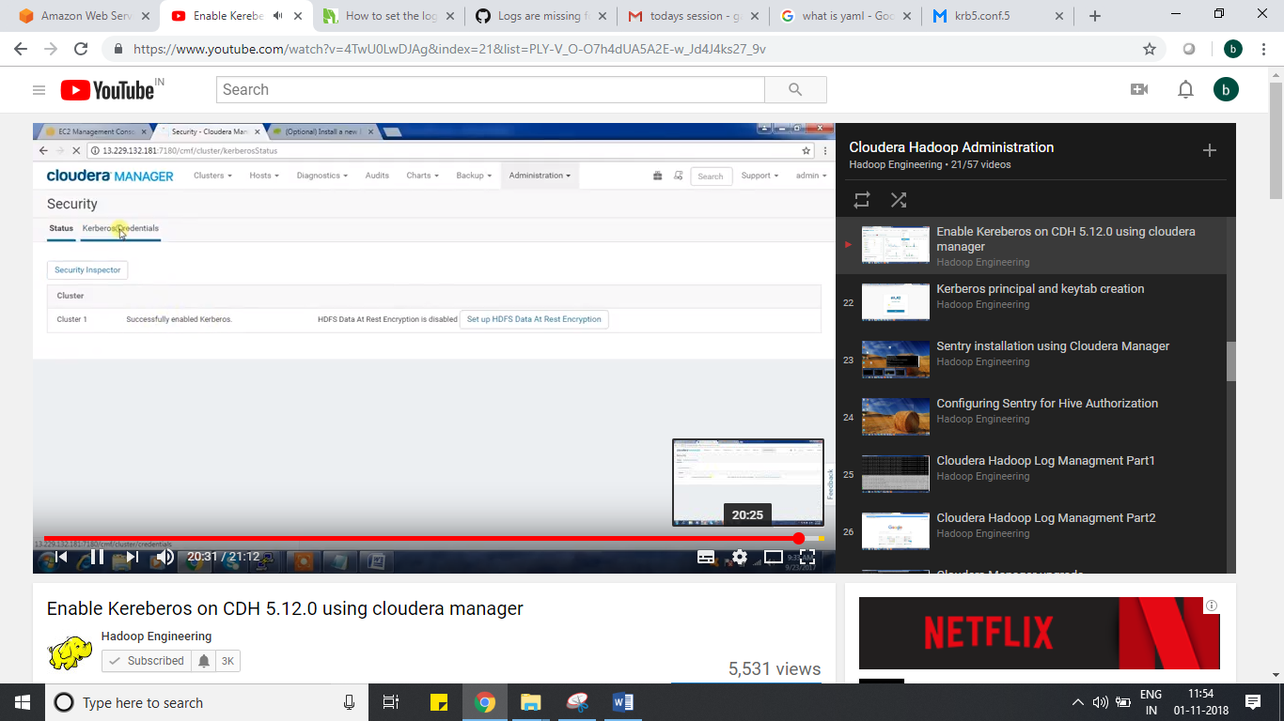

Kerberos credentials if we see we can get list of all principal details here.